Universitatea Tehnica din Cluj-Napoca

***Computer Aided Graphics - Project***

[Draw your reader in with an engaging abstract. It is typically a short summary of the document. When you’re ready to add your content, just click here and start typing.]

[Document subtitle]

***Technical University of Cluj-Napoca***

***Faculty of Automation and Computer Science***

***Department of Automation***

***Discipline: Computer Aided Graphics***

**CAG Project**

|  |  |
| --- | --- |
| **Student : Ilie Teodora** | **Coordinator:** |
| **Group: 30313** | Assist. Eng. Iulia STEFAN |
|  |  |
| 2019-2020 | |

**Summary**

Contents

Explanatory Note 2

Drafting 1 3

Bibliography Drafting 1 3

Drafting 2 4

Bibliography Drafting 2 4

LISP 5

Bibliography LISP 5

OpenGL 6

Bibliography OpenGL 6

**Explanatory Note**

* **Use the current template to finalize the documentation.**
* **For each deadline, continue using this file and the proposed folder structure, by adding the new project part!**
* **At the lab exam, bring the zip file with all the resources (you already sent the final project to a given email address)!**
* **Regarding the Bibliography template, see next:** 
  + **https://www.ieee.org/documents/ieeecitationref.pdf**

**Other resources:**

**[Drafting 1](Drafting%201)**

* *Add a short description of the object and the commands used to finalize the part 1(1/2 pag)*
* *Add pictures of the object.*
* *Add the drawing inside the documentation.*
* *Add the dwg file and other resources into the Drafting 1 folder.*
* *Add bibliography. Do not use wiki.*

The chosen piece is an outer side for canal cable used in installations.

|  |  |
| --- | --- |
| ***Most Used Functions*** | ***Place where the Functions were used*** |
| * *line* | *Axis and covert edges and profiles* |
| * *pline* | *Mostly used for the contour of the piece* |
| * *circle* | *The circle visible from the upper view* |
| * *mtext* | *The text from the indicator* |
| * *tedit* | *Edit the text inside the indicator* |
| * *dimlinear* | *To dimensionate the piece’s edges* |
| * *dimradius* | *To dimensionate the circle in the upper view* |
| * *fillet* | *To create the curved edges in the upper view* |

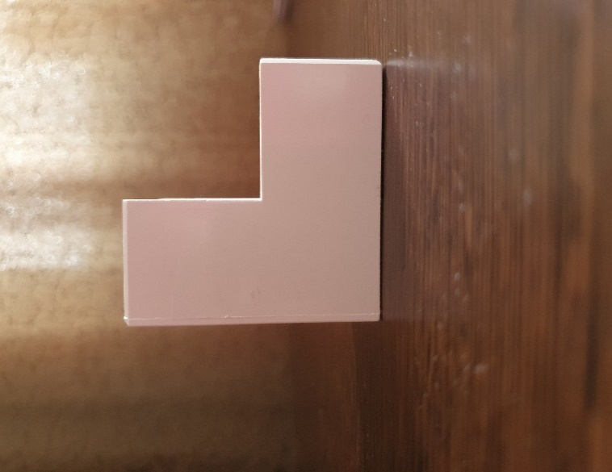 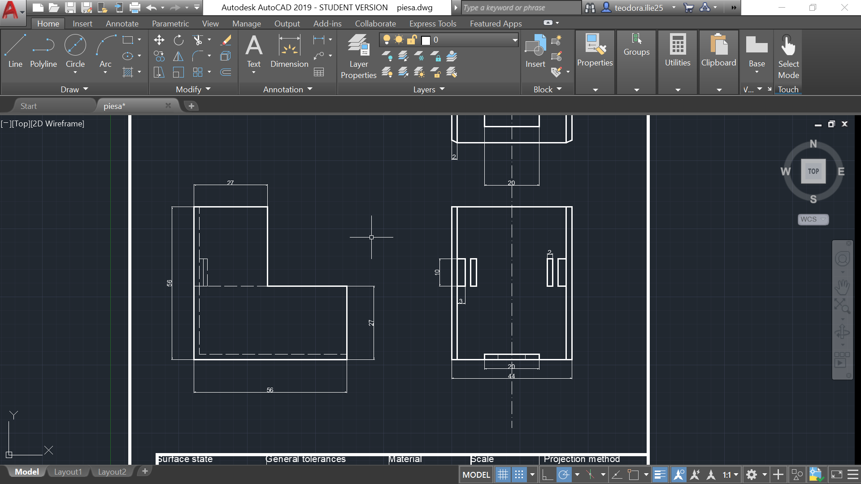

Left view

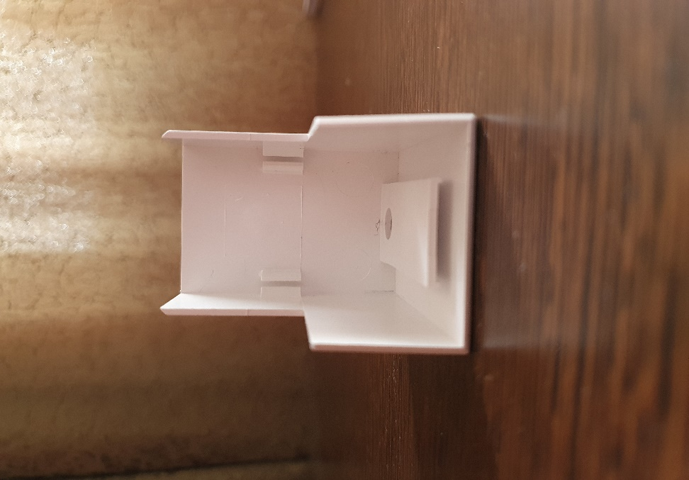 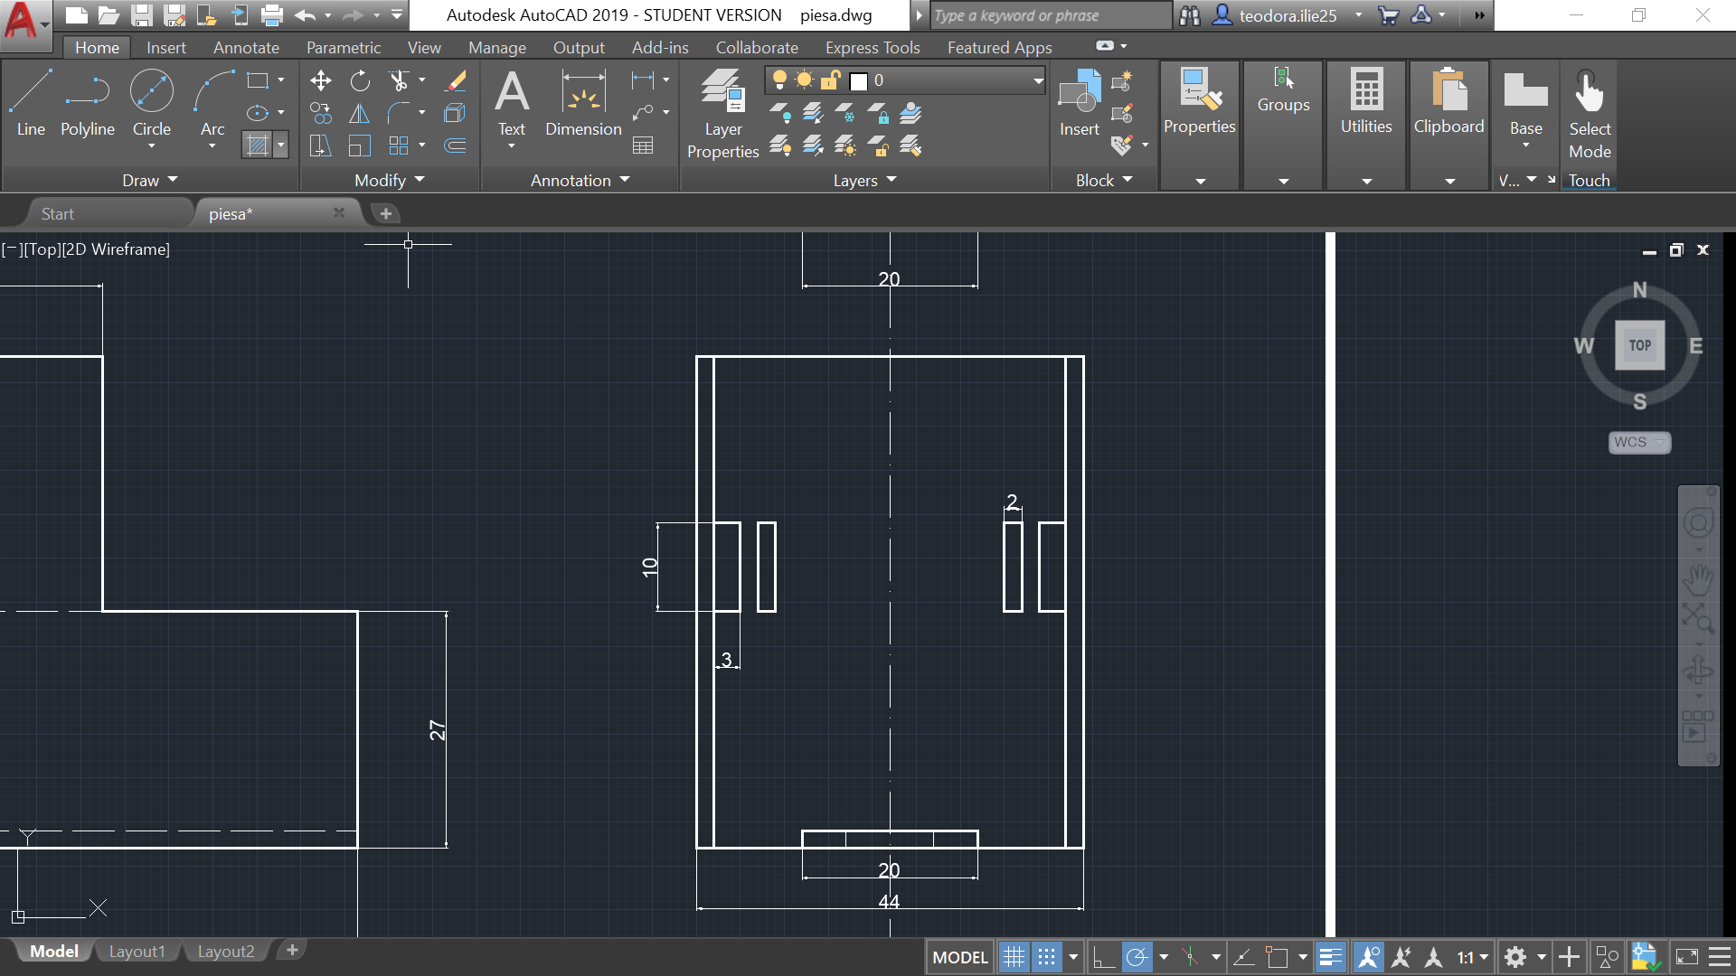

*Front view*

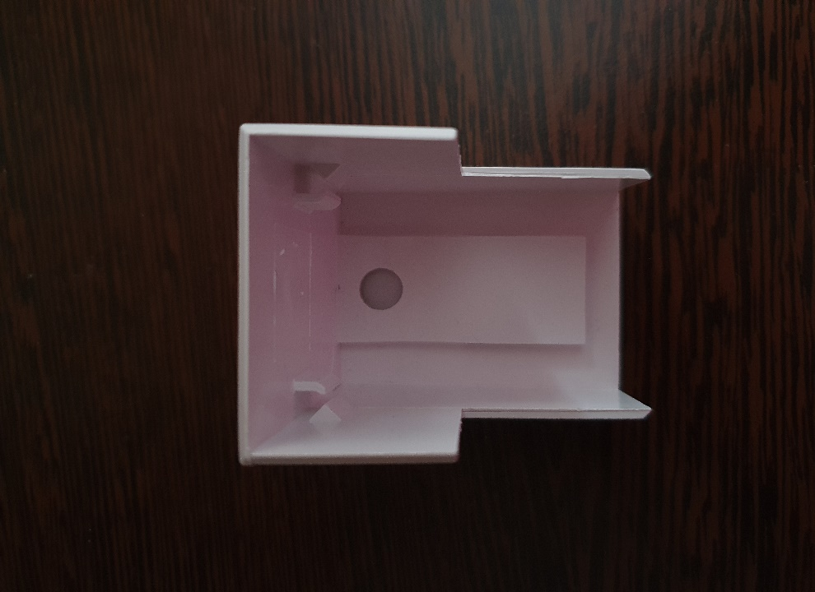 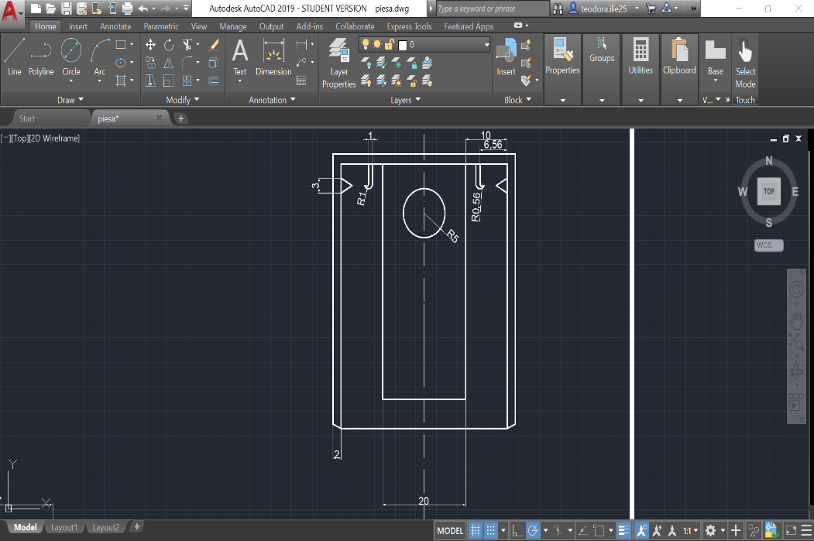

*Upper view*

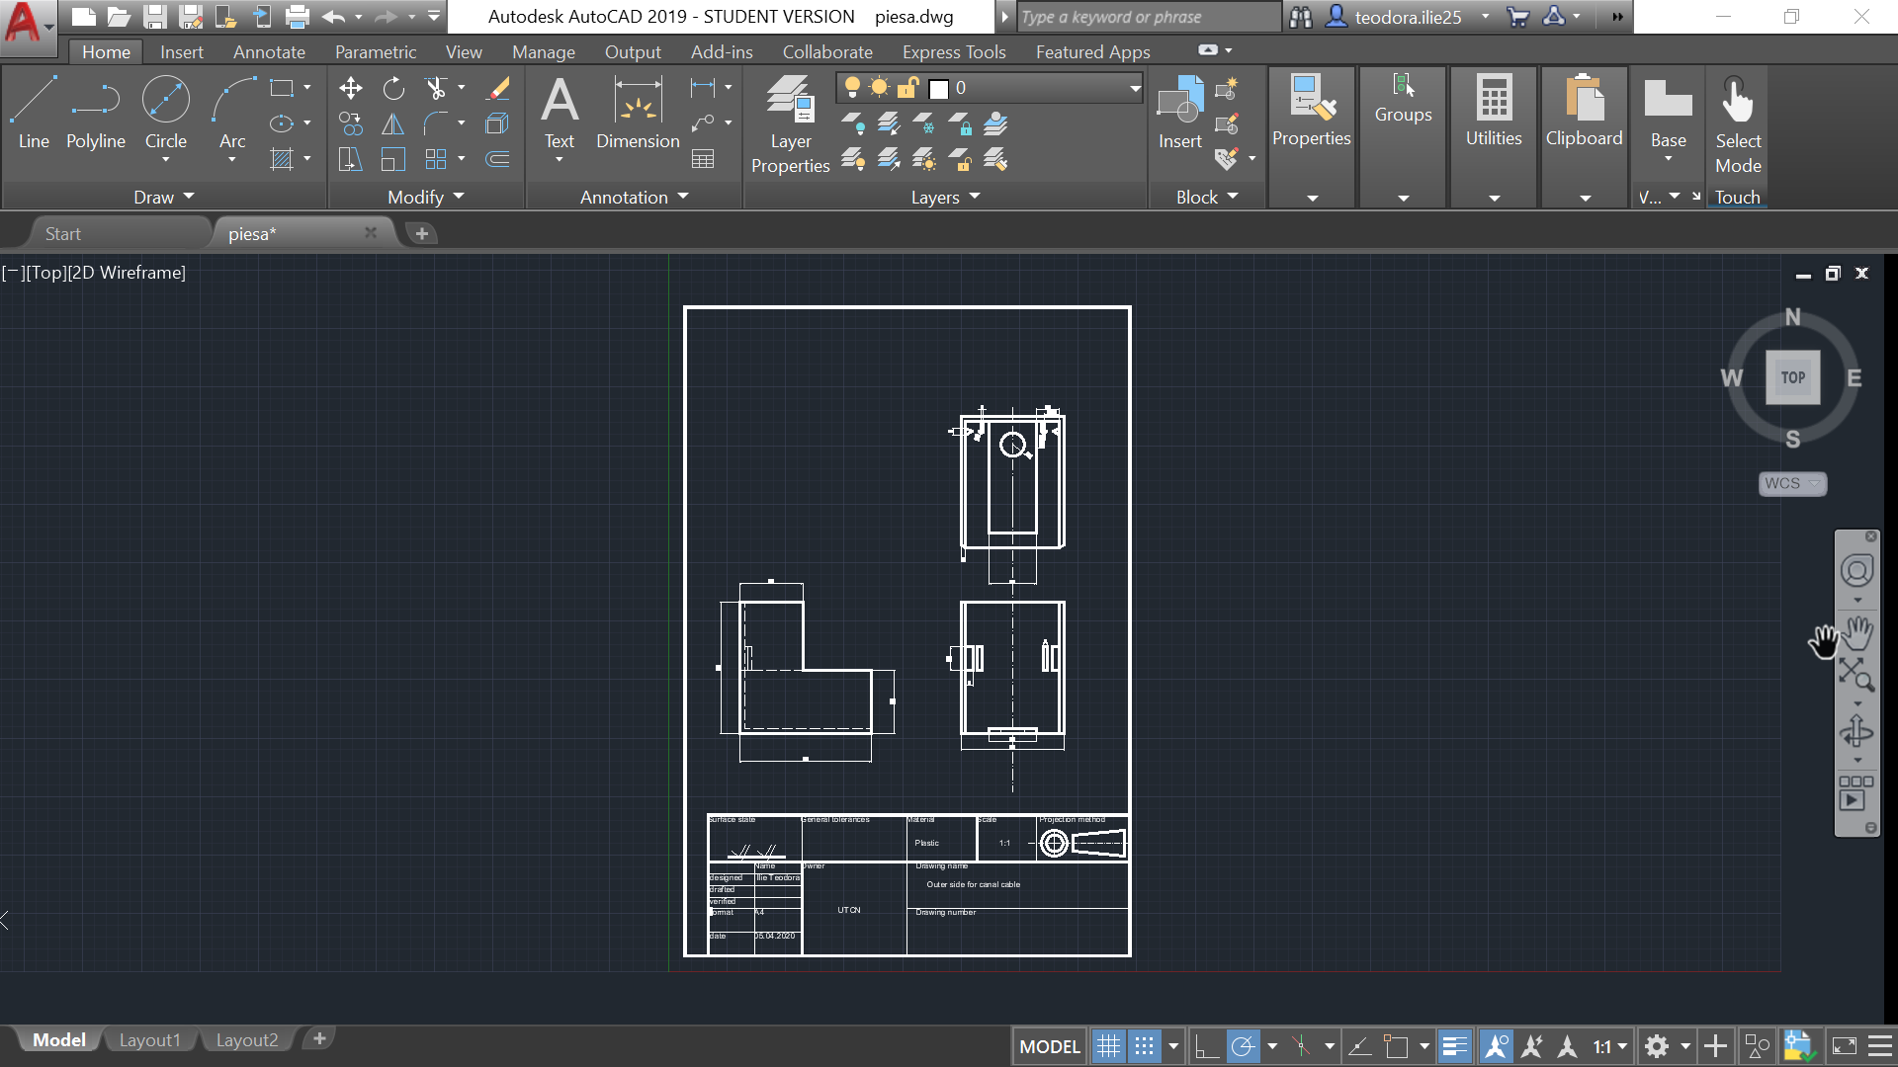

**Bibliography Drafting 1**

1. <https://materialedeconstructie.files.wordpress.com/2010/10/desen-tehnic.pdf>
2. <http://users.utcluj.ro/~iuliapopa/lcr/acd/norme_generale/Norme%20generale%20pentru%20reprezentarile%20grafice%20industriale%20rom.pdf>

**[Drafting 2](Drafting%202)**

* *Add the description of the process and the commands used to finalize the part 2(1 pag)*
* *Add the dwg file or other resources into the Drafting 2 folder.*
* *Add the drawing inside the documentation (doc file).*
* *Add the bibliography used (hyperlinks or other). Do not use wiki.*

|  |  |  |
| --- | --- | --- |
| INSTRUMENT ABBREVIATION | MEANING OF THE ABBREVIATON USED | FUNCTION |
| FT | Flow Transmitter | Measuring flow and transmitting it to FIC |
| FIC | Flow Indicator and Controller | Receives flow value from FT and controls flow entering process vessel by controlling the opening and closing of the manual valve with actuator |
| TT | Temperature Transmitter | It measures temperature and transmits the value electronically to TIC which in turn is used to control a control valve |
| SL | Solenoid | Its function is to receive electrical signal and allow the control of the manual valve with actuator though pneumatic signals |
| TIC | Temperature Indicator and Controller | Receives measured temperature signal from TT and uses this value to control and control valve |
| WR | Weight Recorder | Continuously records the weight of process fluid transmitted to it by WT |
| WT | Weight Transmitter | Measures the weight of process fluid in the process vessel and transmits its value electronically to WR |

**Bibliography Drafting 2**

1. <http://users.utcluj.ro/~iuliapopa/lcr/acd/rom/AUTOCAD%20P&ID%20ro.pdf>
2. <https://knowledge.autodesk.com/support/autocad-plant-3d/learn-explore/caas/CloudHelp/cloudhelp/2018/ENU/Plant3D-UserGuide/files/pid-drawing-design-add-instruments-wkflw-htm.html>
3. <http://users.utcluj.ro/~iuliapopa/lcr/acd/norme_generale/ANSI%20ISA%205.1%201984%20(R1992)%20Instrumentation%20Symbols%20and%20Identification.pdf>

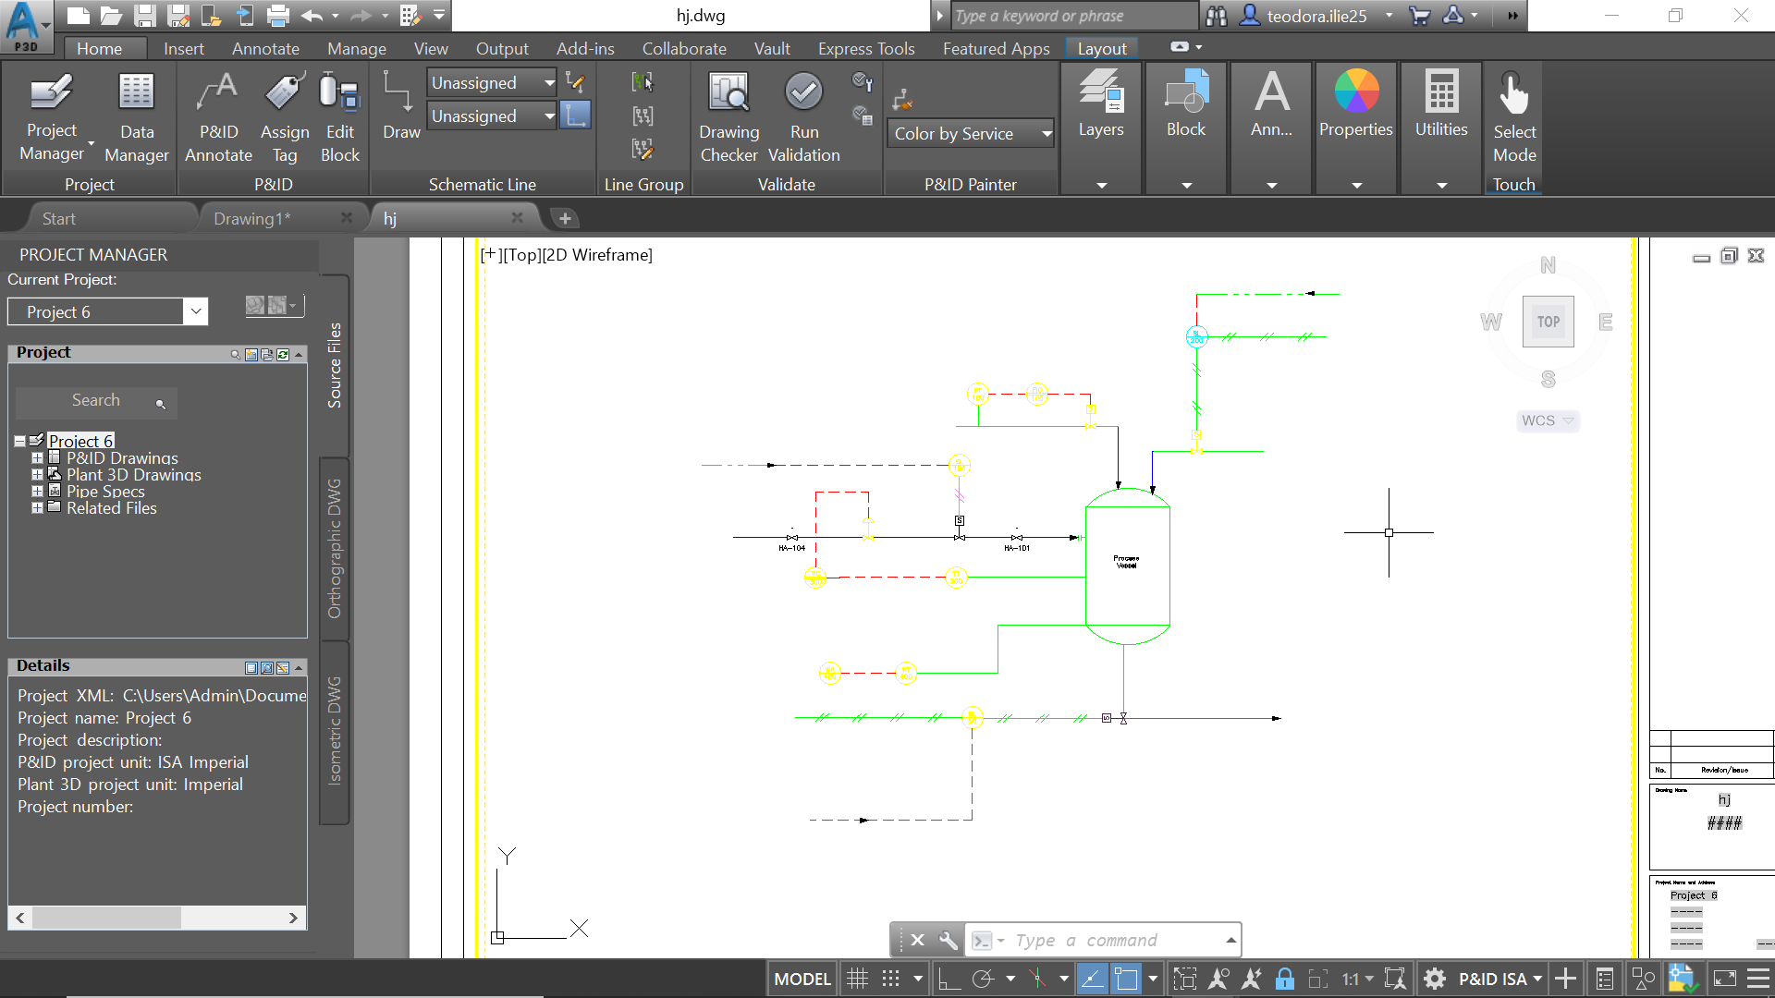

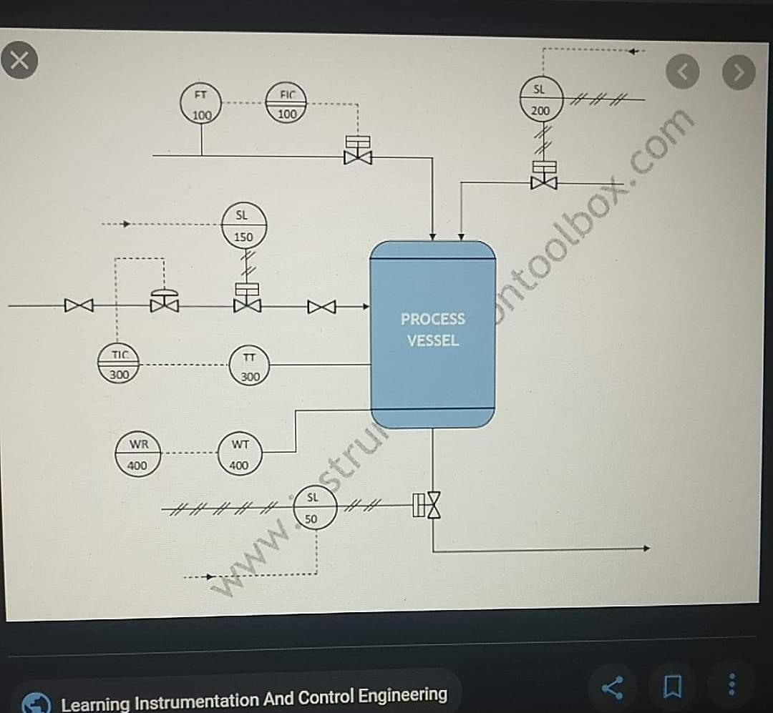

**[LISP](Lisp)**

* *Add description of the program.*
* *Add the source code with comments.*
* *Add the lsp file and*  other *resources, if needed, into the LISP folder.*
* *Add print screens with before and after usage of the command you created.*
* *Add the Bibliography used (hyperlinks or other). Do not use wiki.*

My function, named circleinsquare, was made to introduce each circle from the dwg file in a square.

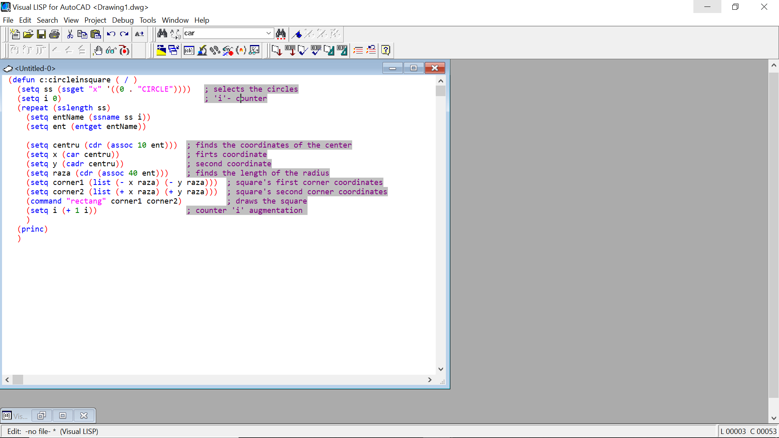

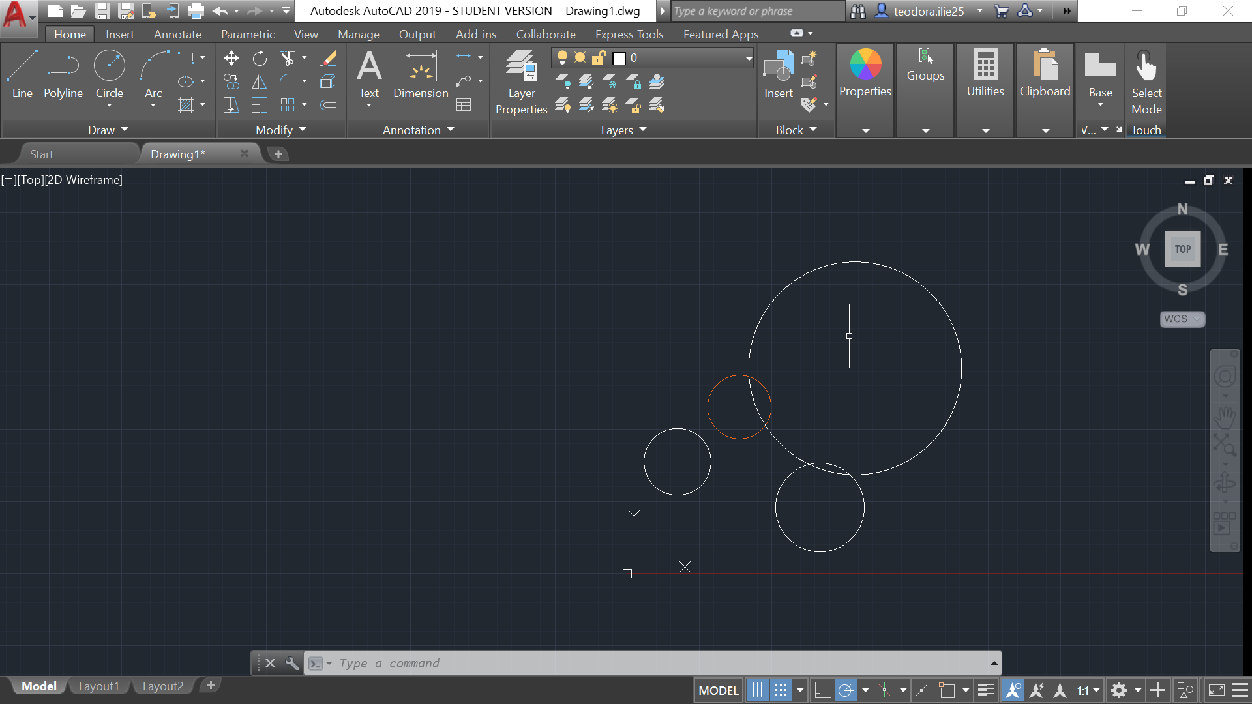

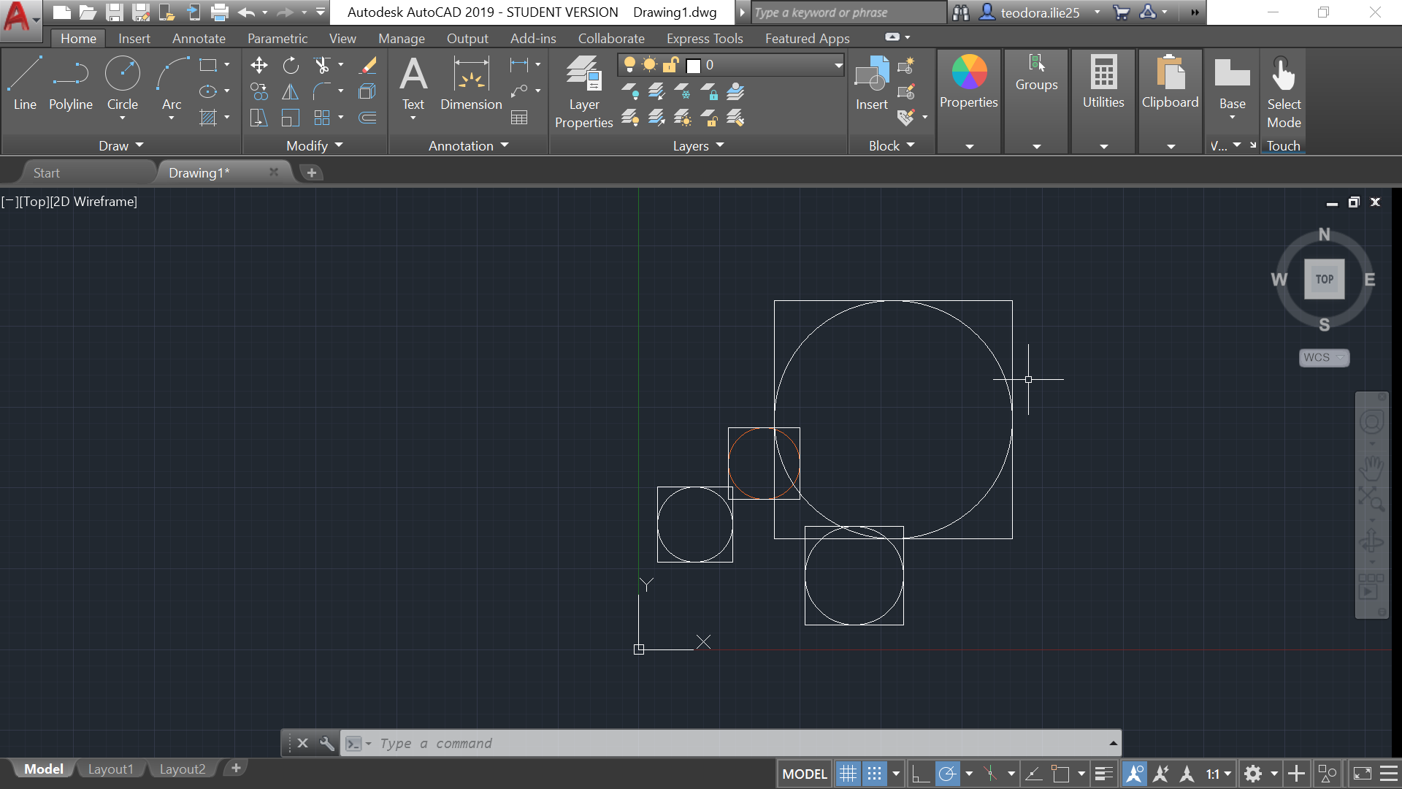

**Bibliography LISP**

1. <https://www.cadtutor.net/forum/topic/33107-extract-center-point-and-diameter-of-circle-then-use-these-values-in-a-routine/>
2. <https://www.afralisp.net/reference/dxf-group-codes.php>
3. <http://users.utcluj.ro/~iuliapopa/lcr/acd/rom/lisp_lab-07-08_ro.pdf>

**<OpenGL>**

* *Add the objective and a short description of the program.*
* *Add the source code with comments.*
* *Add print screens of the output window.*
* *Add the cpp or the entire project into the folder OpenGL.*
* *Add the Bibliography used (hyperlinks or other). Do not use wiki.*

*The project is composed of 4 squares of different colors. Three of them are moving while the 4th one is in the middle of the screen.*

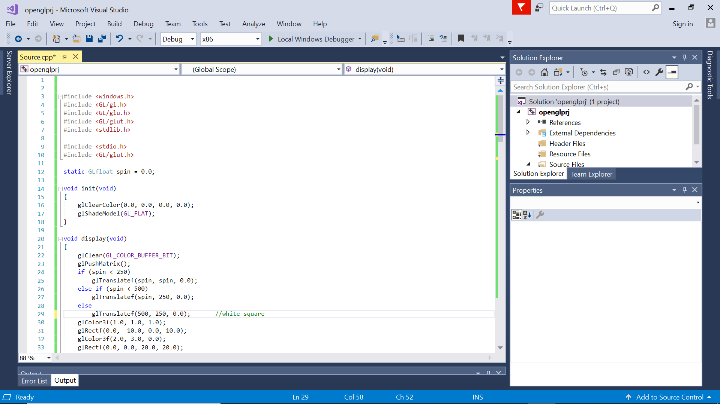

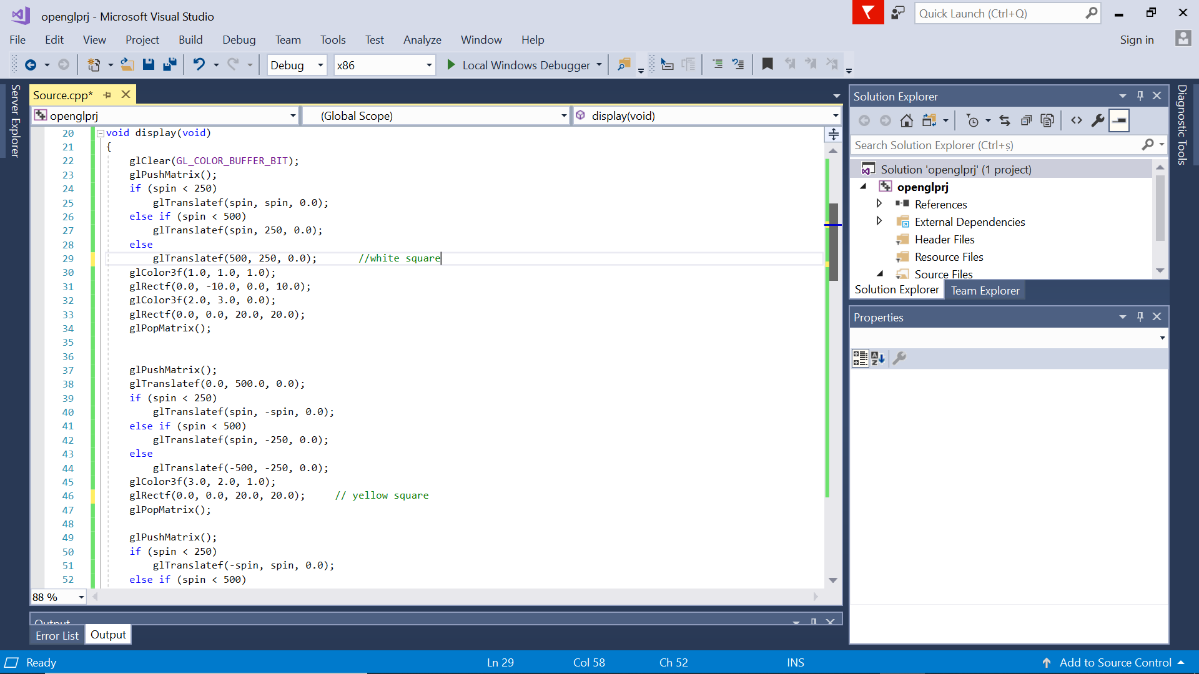

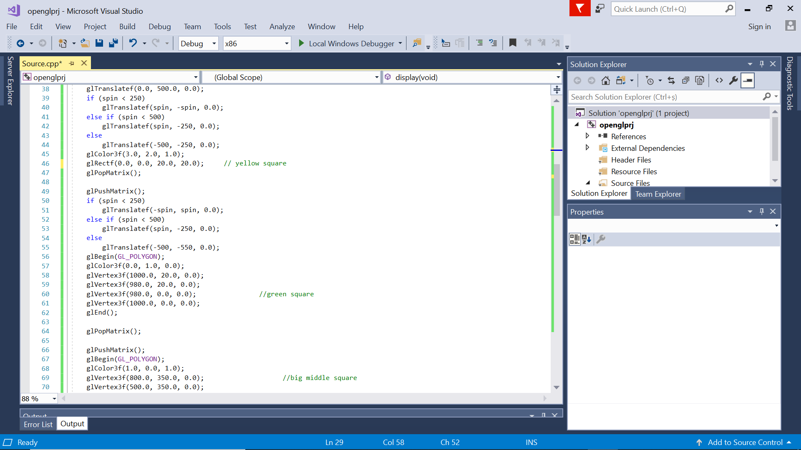

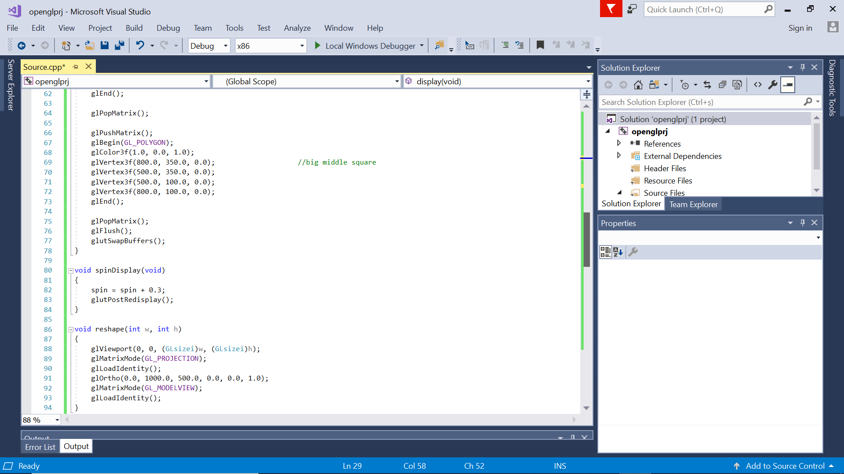

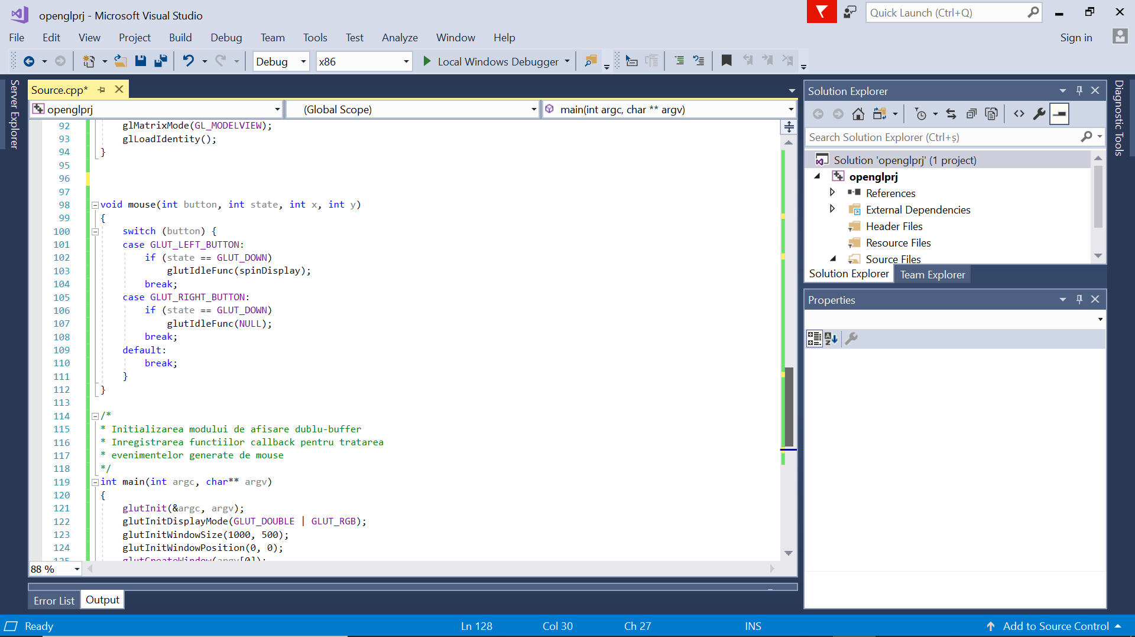

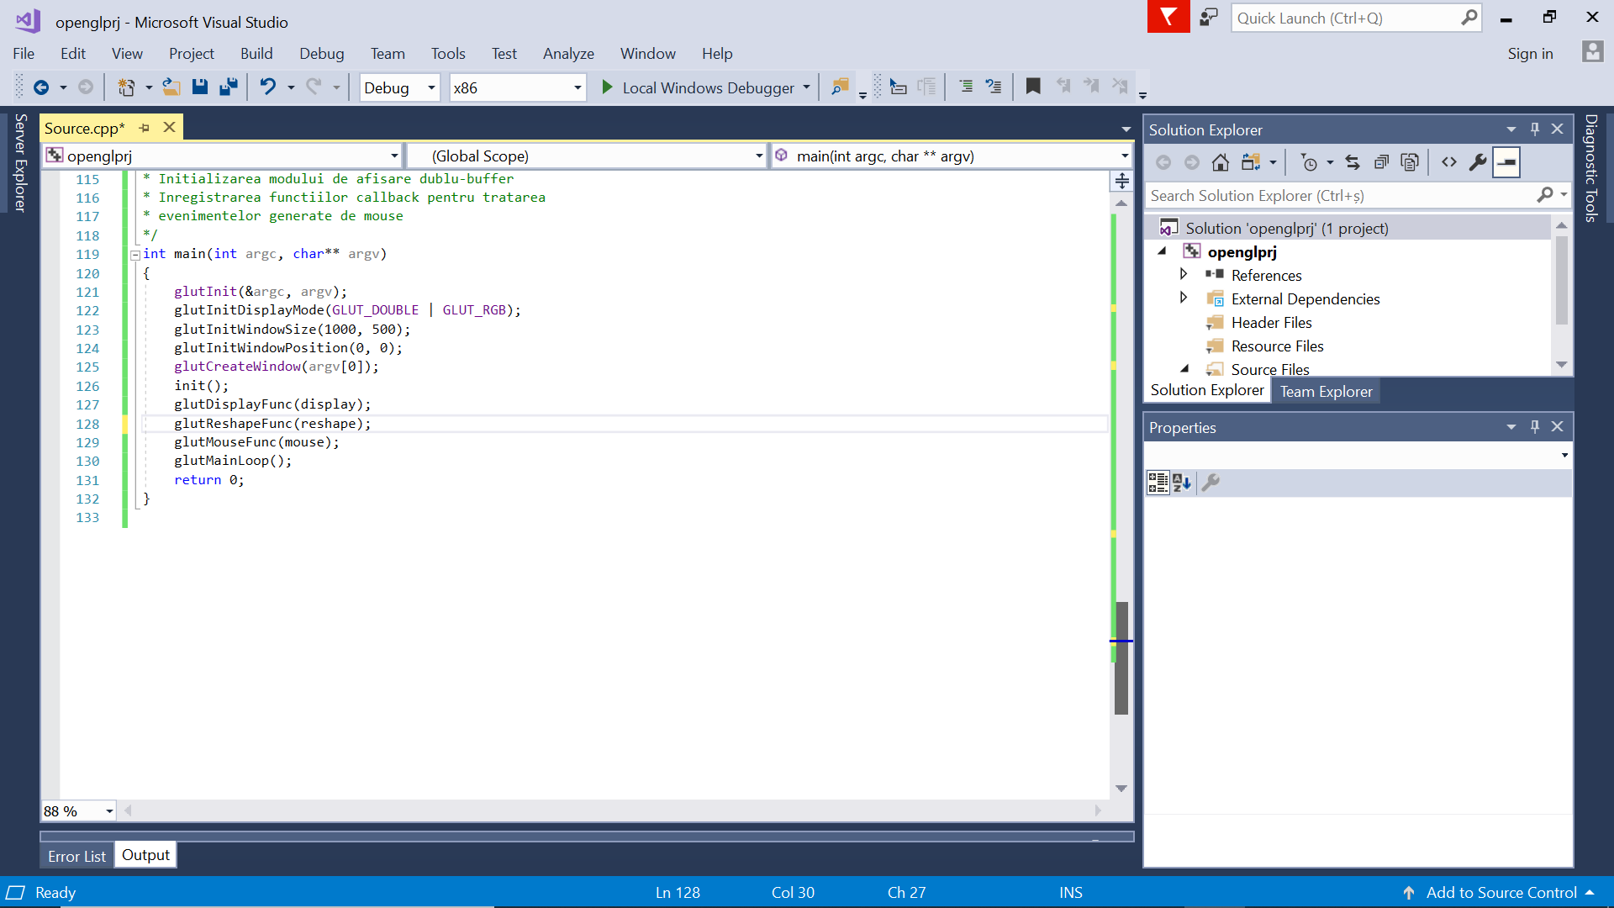

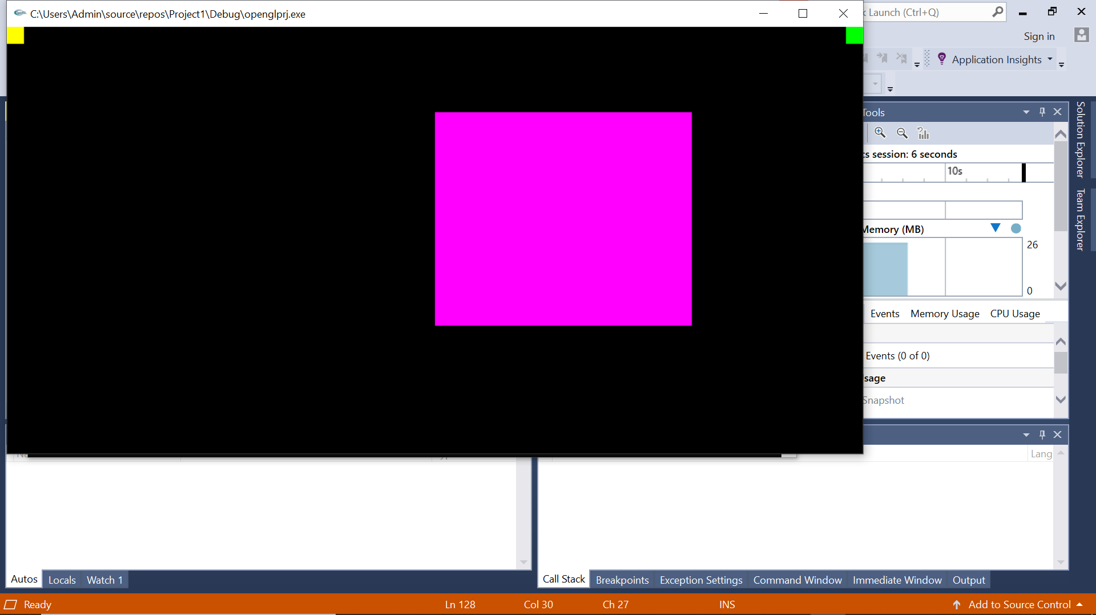

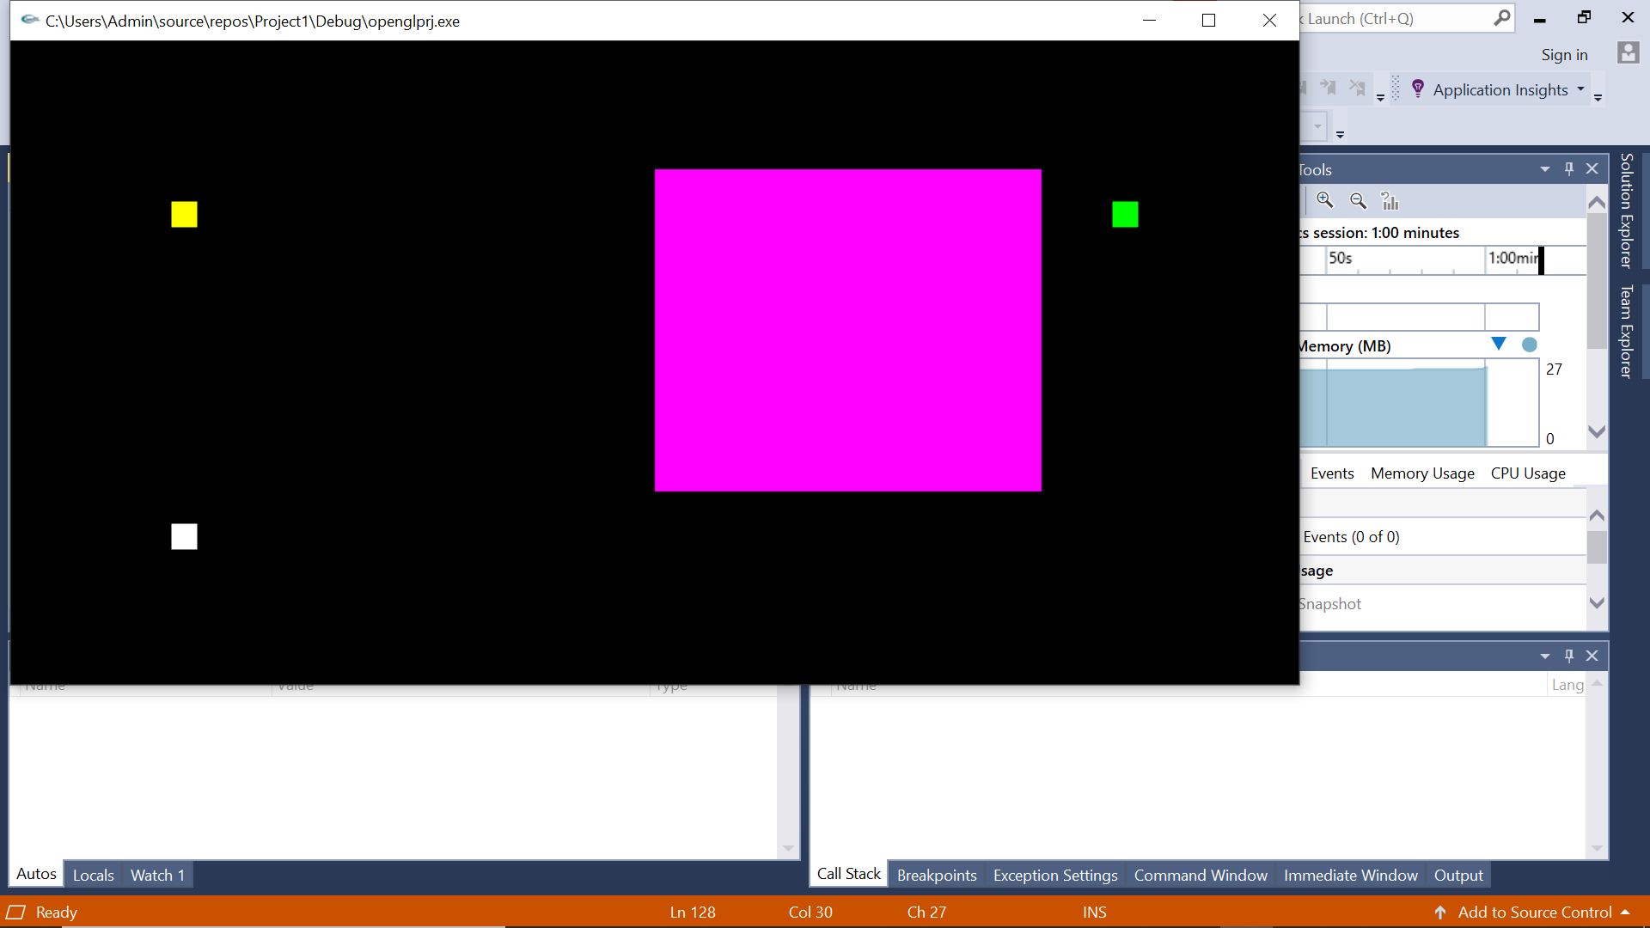

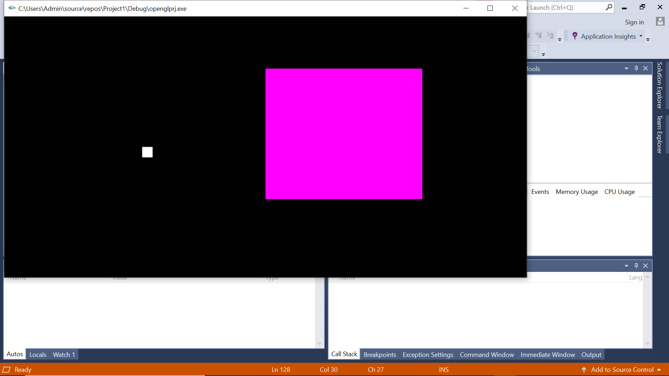

**Bibliography OpenGL**

1. <https://blog.projectmaterials.com/flanges/flange-types-piping>, last visited: the day month year.
2. Autori, Nume carte/capitol/articol, Editura/Revista/Conferinta, an apartitie, pp. x-y
3. etc